**PROJECT STATUS REPORT : Remaining Useful Life (RUL) Prediction on CMAPSS Dataset**

**D Girishkanna**

## **Project Overview**

In this project, the Remaining Useful Life (RUL) of aircraft engines is predicted based on the C-MAPSS dataset from NASA's Prognostics Data Repository. The RUL is actually the number of cycles an engine will run before failing, and precise forecasting of it can help in optimizing maintenance scheduling as well as preventing unexpected downtimes.

In order to solve this issue, a mixture of classical machine learning models was used. Not only was it aimed at predicting the RUL of engines, but also at comparing the performance of various methods with regards to accuracy, computational complexity, and adaptability for time-series degradation data.

### **Dataset Description**

The C-MAPSS dataset consists of time-series sensor readings and operational parameters of several engines. There are a series of engines which are run-to-failure under a range of operating conditions, and sensor readings are taken at every operating cycle. The dataset employed in this work, train_FD001.txt, consists of data for the single operating condition and single fault mode.

Each entry contains an engine unit number, cycles time, three operational settings and 21 sensor readings. The target variable, Remaining Useful Life (RUL), was calculated by finding the maximum number of operating cycles for each engine and subtracting the current cycle number from it.

### **Data Preprocessing**

The preprocessing step included a number of crucial steps. The first step was loading the raw data into a Pandas DataFrame, and suitable column names were given for readability purposes. The RUL for every record was computed by determining the difference between the maximum cycle and the current cycle for every engine unit.

Subsequently, the operational conditions and sensor measurements were normalized with MinMaxScaler to have the features scale from 0 to 1. This scaling is important, particularly with neural networks, to avoid problems that arise when features have varying numerical scales. Lastly, the dataset was separated into a training set and a validation set while maintaining the temporal sequence of engine cycles, which is essential for time-series modeling.

### 

### **Traditional Machine Learning Models**

Four regression models were initially trained on preprocessed data: Linear Regression, Ridge Regression, Lasso Regression, and Random Forest Regressor. These models consider each record in isolation, ignoring the sequence of sensor measurements in time. In spite of this limitation, they are useful baselines to measure the gain of sequential models.

Both models were trained to predict RUL using the scaled features. Model performance was also checked by traditional regression metrics like Root Mean Squared Error (RMSE), Mean Absolute Error (MAE), and the R² score. Apart from numerical assessment, scatter plots of actual vs. predicted RUL values were also generated to qualitatively evaluate the quality of prediction.

To see which of the features had the greatest impact on the RUL predictions, feature importance scores were obtained from the Random Forest model. This gave informative results of which operating conditions and sensor readings had the greatest influence on predicting the RUL.

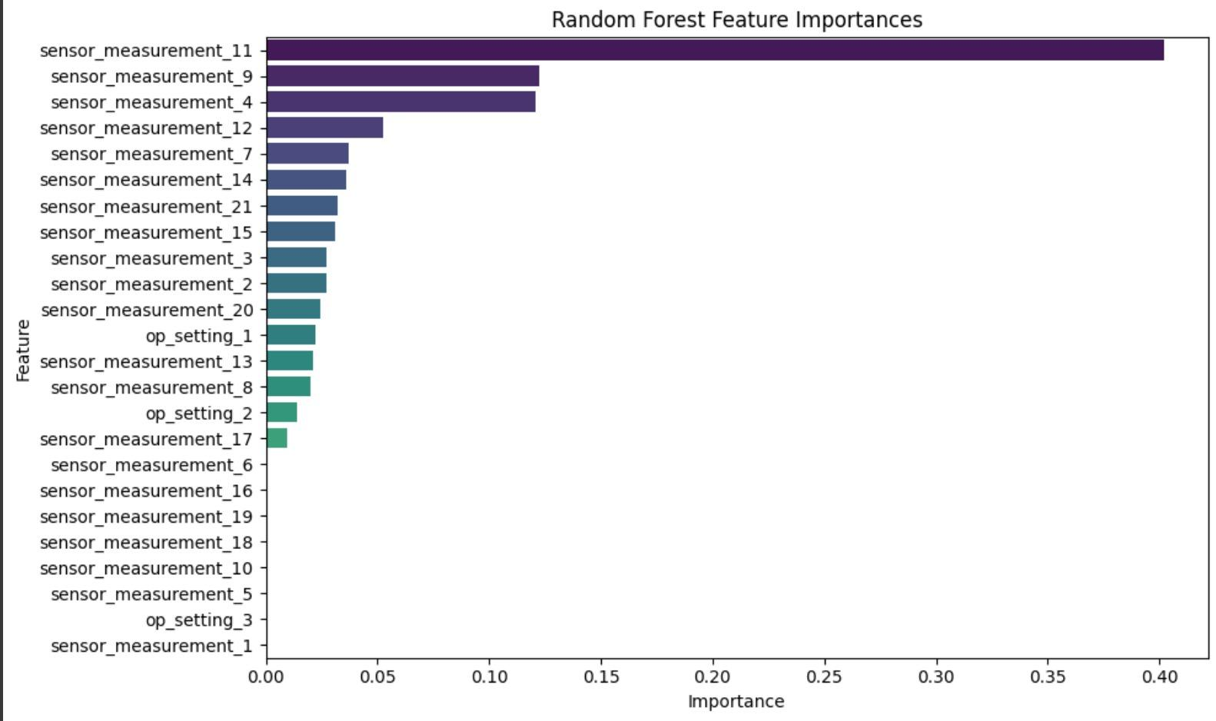

### **Hyperparameter Tuning**

To enhance the performance of the machine learning models of the past, hyperparameter tuning was done with RandomizedSearchCV. This entailed defining ranges of hyperparameters for the different models and letting the search algorithm find the optimal combination according to cross-validation performance. Tuning resulted in significant improvements, especially for the Random Forest model, which achieved significant increases in accuracy and R² score.

### **Model Performance Comparison**

Once all models were trained and tested, their respective performance metrics were summarized into a comparison table. The Random Forest Regressor was the top-performing traditional model, surpassed only by the linear models in both error measures and R² score. Nevertheless, the LSTM model far outranked all the others, with the lowest RMSE and MAE, as well as the highest R² score, validating the strength of sequence-based models for this kind of predictive maintenance task.

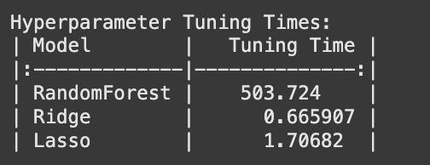

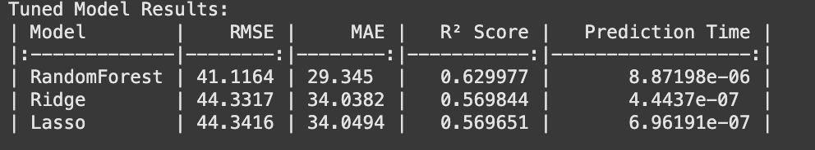

### 

### **Conclusion**

We were able to effectively showcase an end-to-end solution to estimating Remaining Useful Life (RUL) via classical models and deep learning models. Classical machine learning models gave acceptable performance and insightful interpretability in the form of feature importance analysis.

The results highlight the need to consider sequential dependencies in time-series data handling when used in prognostics applications. Additionally, the synergy between hyperparameter tuning and suitable data preprocessing was crucial for fine-tuning model performance in both traditional and deep learning methods.

